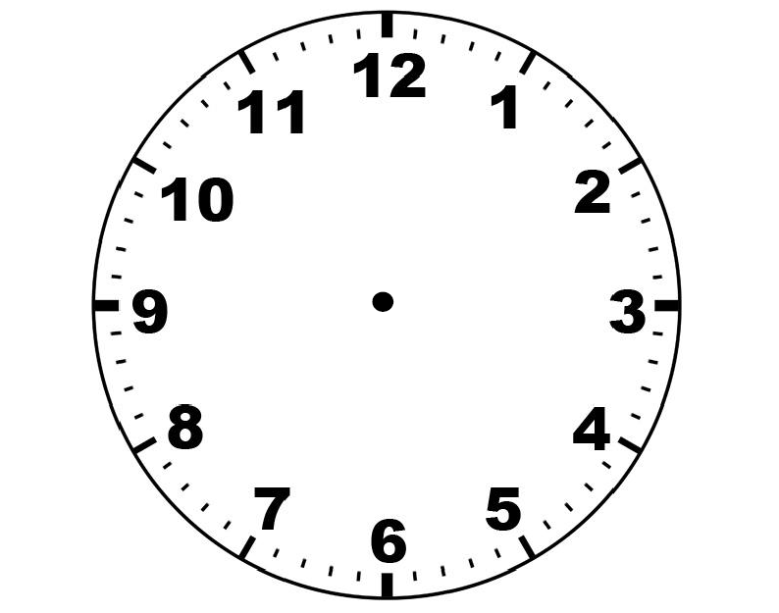

For getting the time display in the clock . We will use JavaScript 🡪 New Date() function

* New Date().getMinutes()
* New Date().getHours()
* New Date().getSeconds ()

So we have to rotate the hands of the clock

1. The Hour hand

Let the hand on 12

12 hours = 360deg

1 hour = 360/12

= 30deg

So the formula is –

H hours = 12h deg

1. The Minute Hand

Let the minute hand on 12

60min = 360deg

1 min = 360/6

= 30deg

So the formula is –

H hours = 12h deg